**Laboratory work #1**

**INVESTIGATION OF TIME AND SPECTRAL**

**CHARACTERISTICS OF MODULATED SIGNALS.**

**Belarusian State University**

**Author:Yuan Shaochen**

**City：Minsk**

**E-mail：elysiashaochen@gmail.com**

1.Assemble the device required for the experiment,as shown in the figure: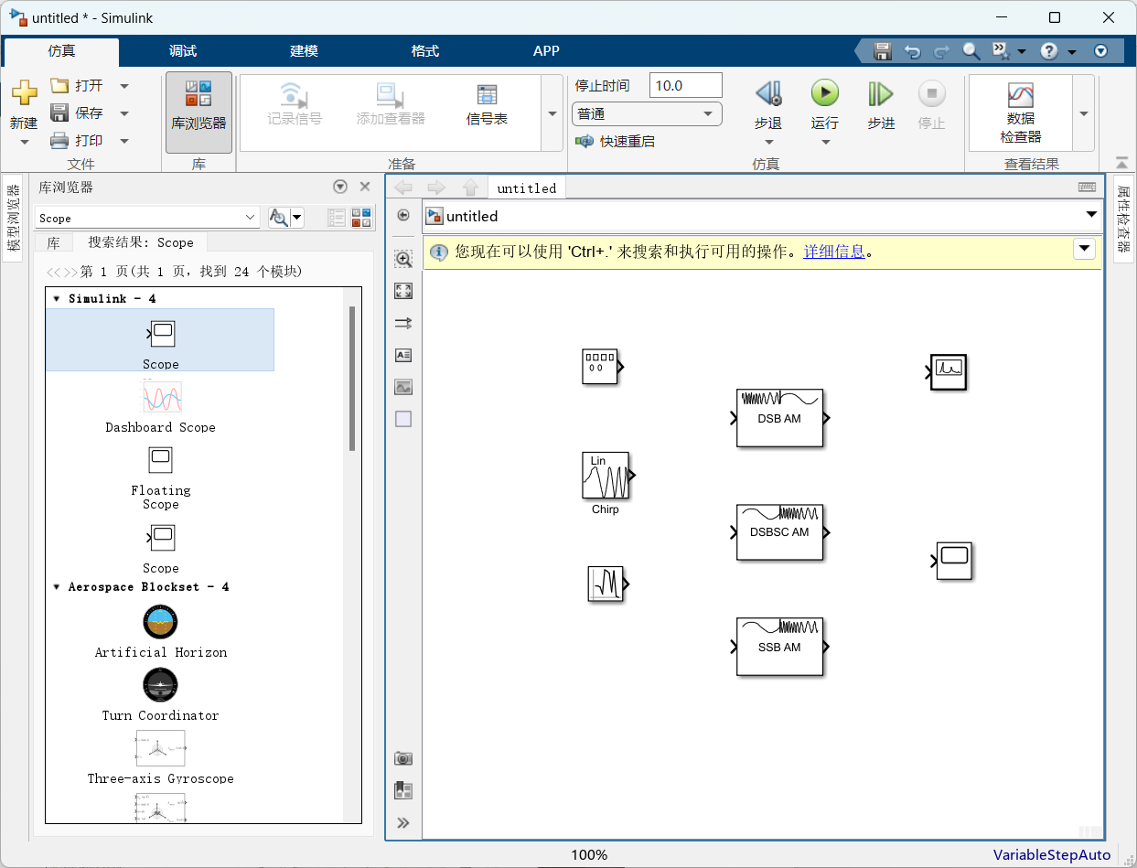

The sine wave, rectangular wave and triangular wave are studied respectively. The frequency and amplitude of the oscillation and the results are shown in the figure: Amplitude:7, Frequency: 10

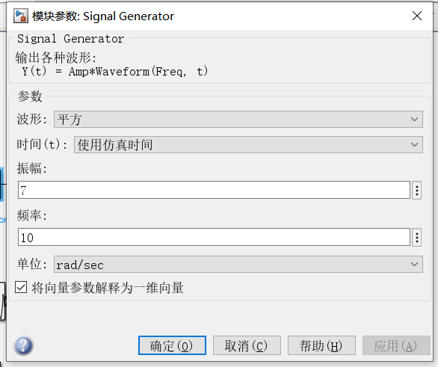

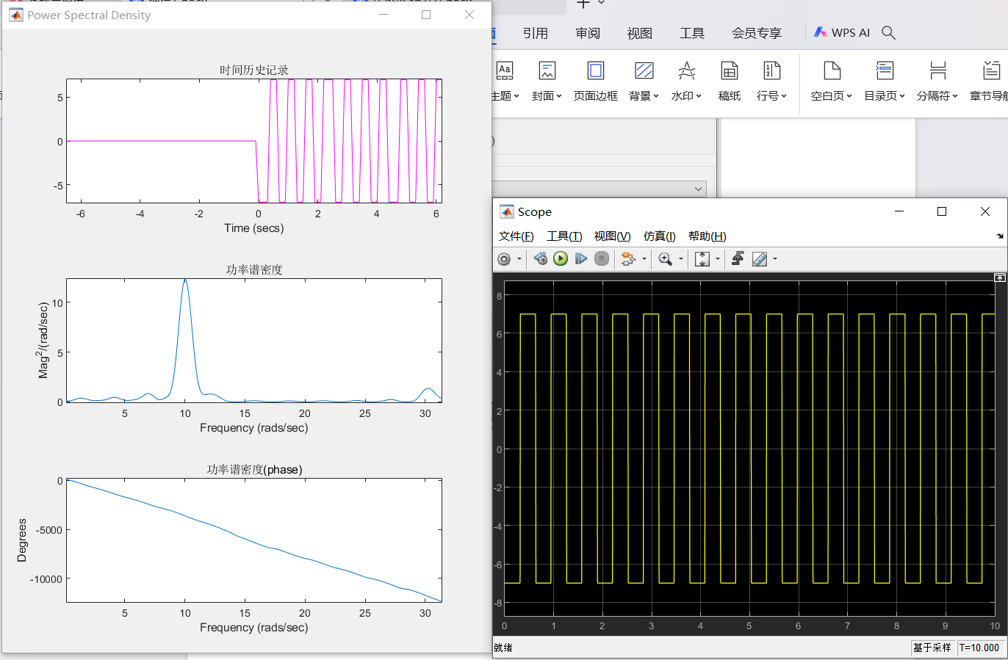

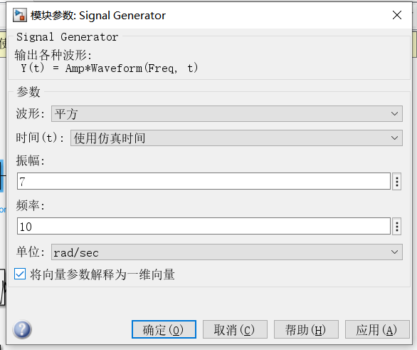

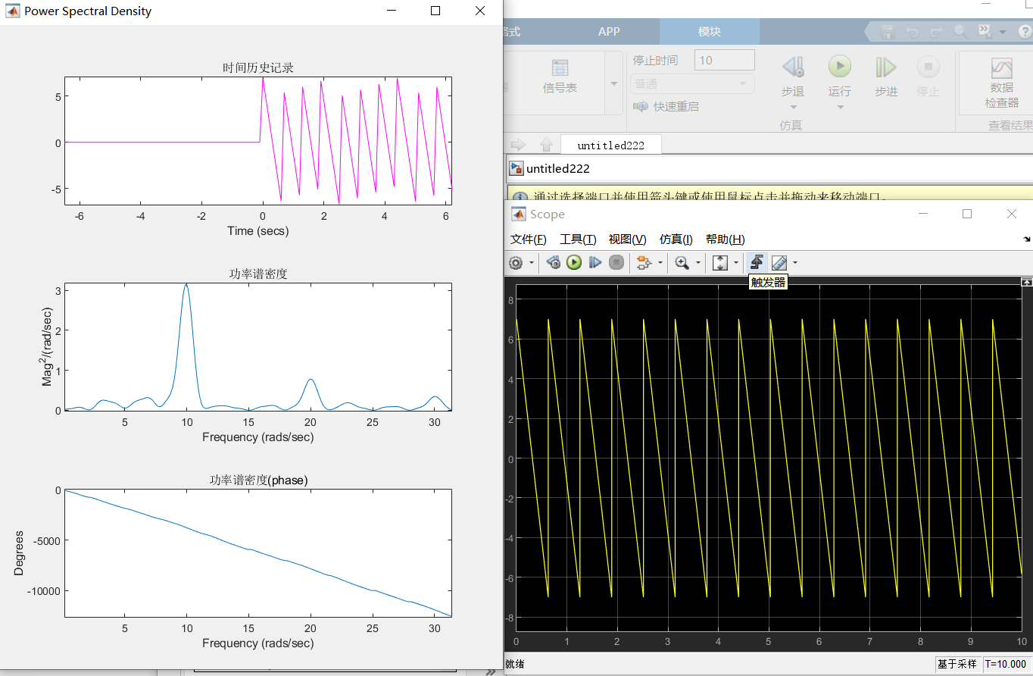

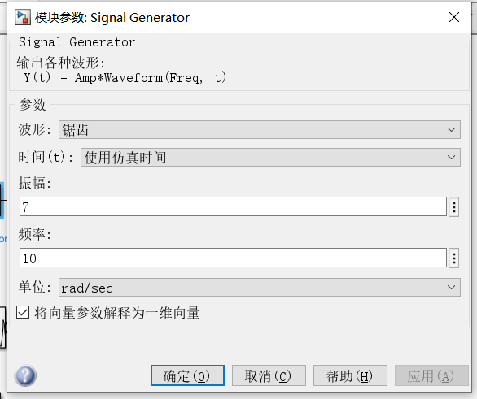

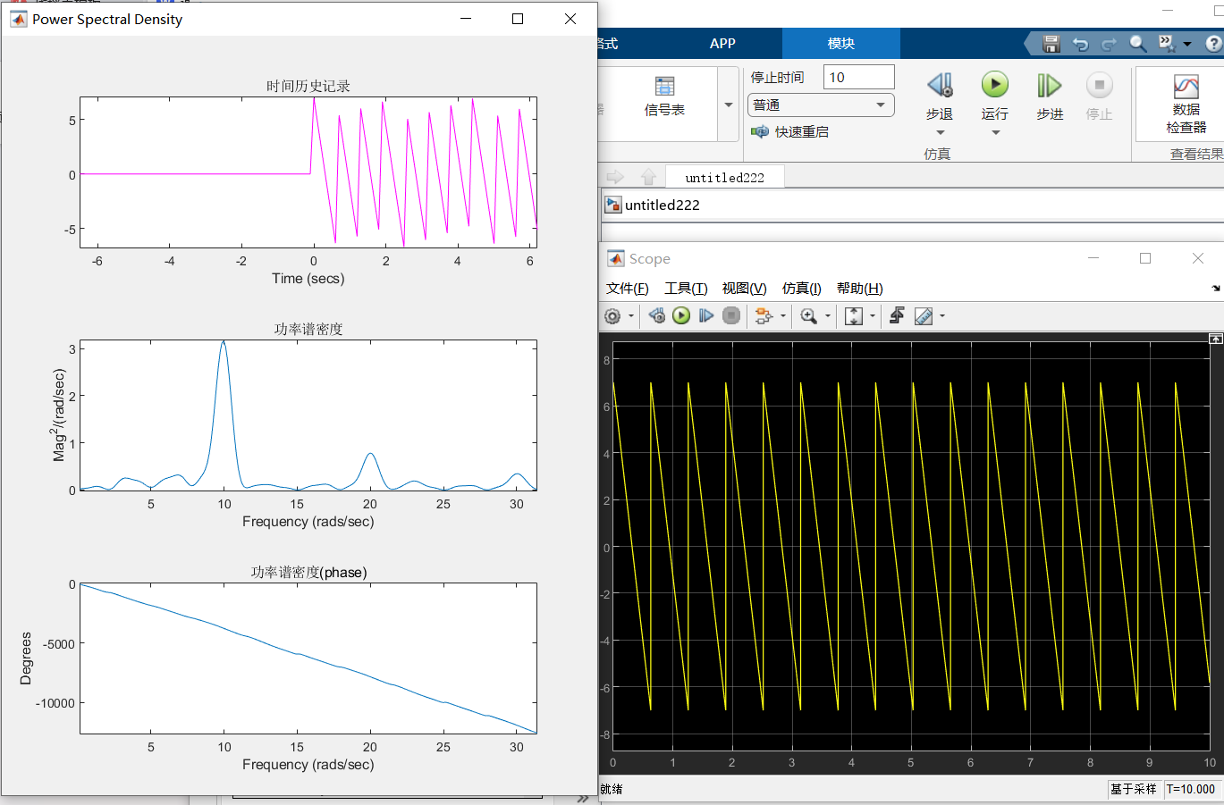

In order to study the oscillation characteristics of the "Chirp" signal generator, the unidirectional and bidirectional modes are studied respectively, and the starting and ending frequencies and results are shown in the figure:

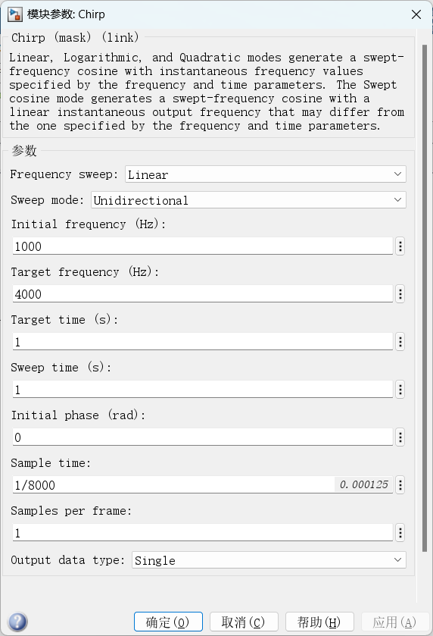

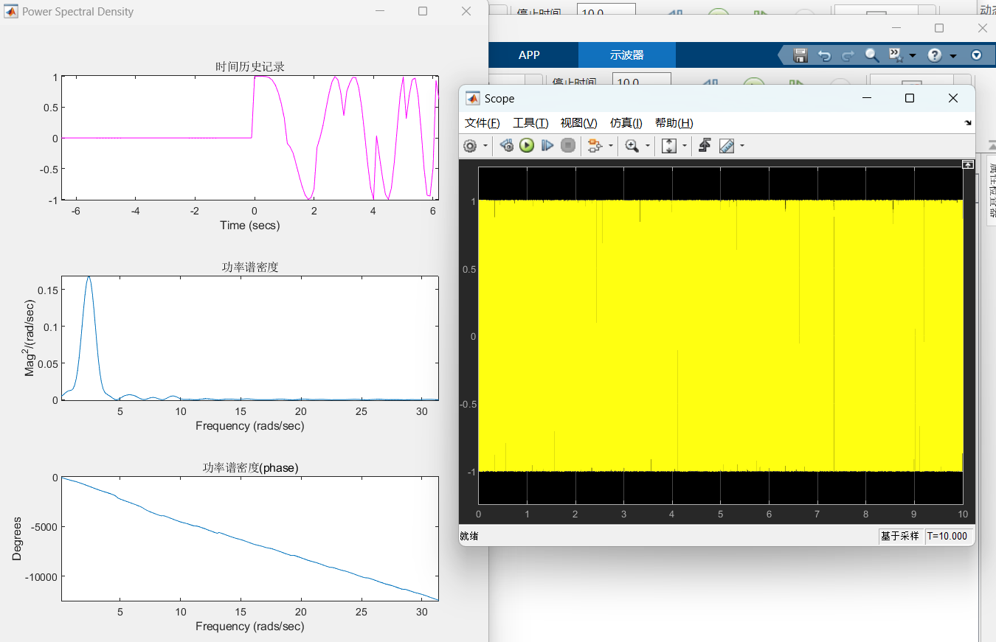

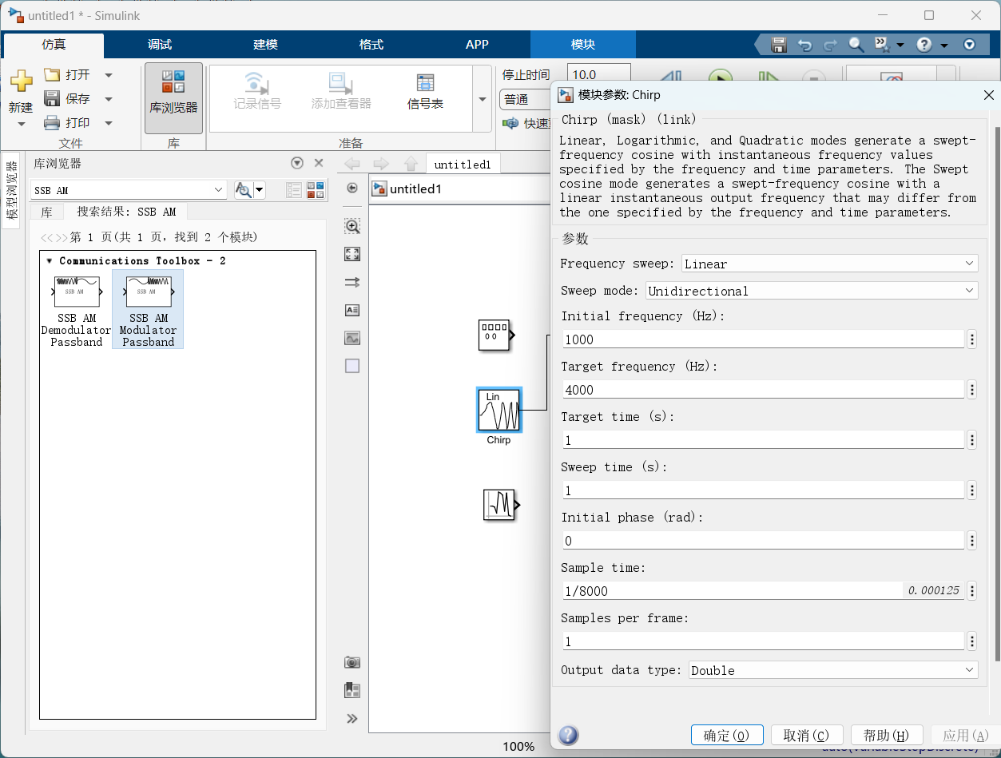

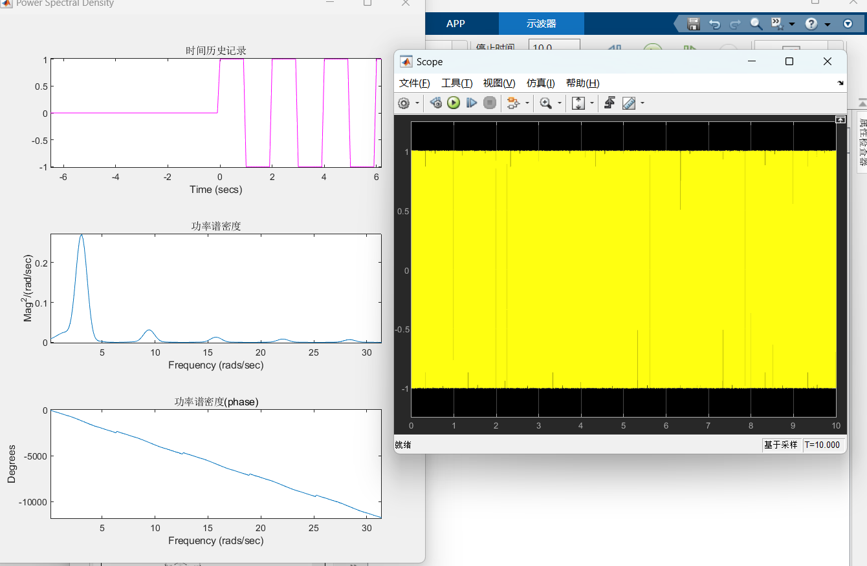

Study the oscillation characteristics of the random number generator and execute the results, as shown in the figure:

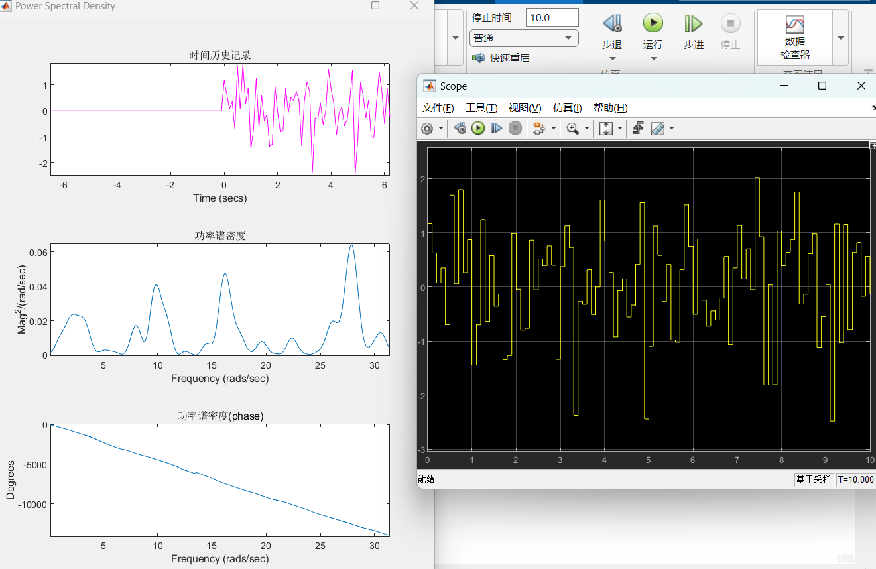

2.Composing a new laboratory setup, taking a sine wave, increasing the frequency of 5 the signal generator by 50Hz relative to the initial data, and then decreasing it by 50Hz, the following results are obtained: 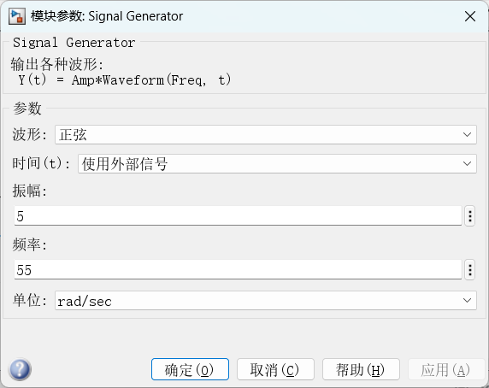

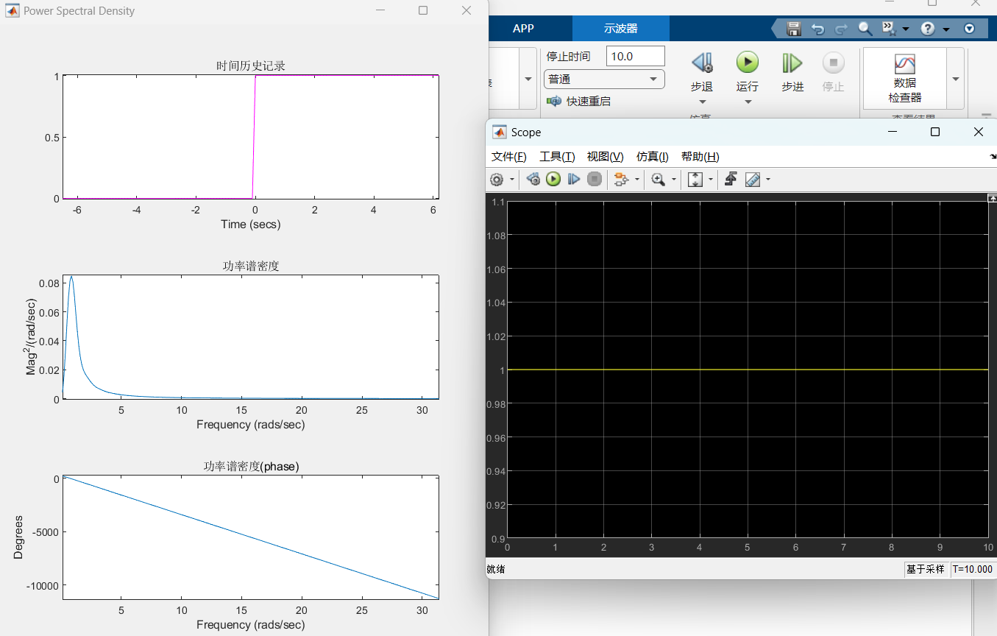

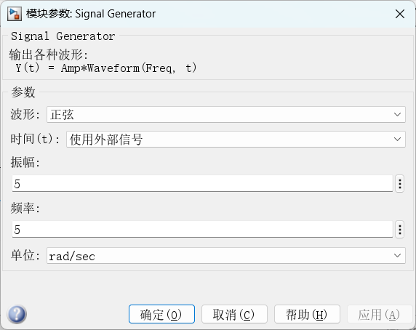

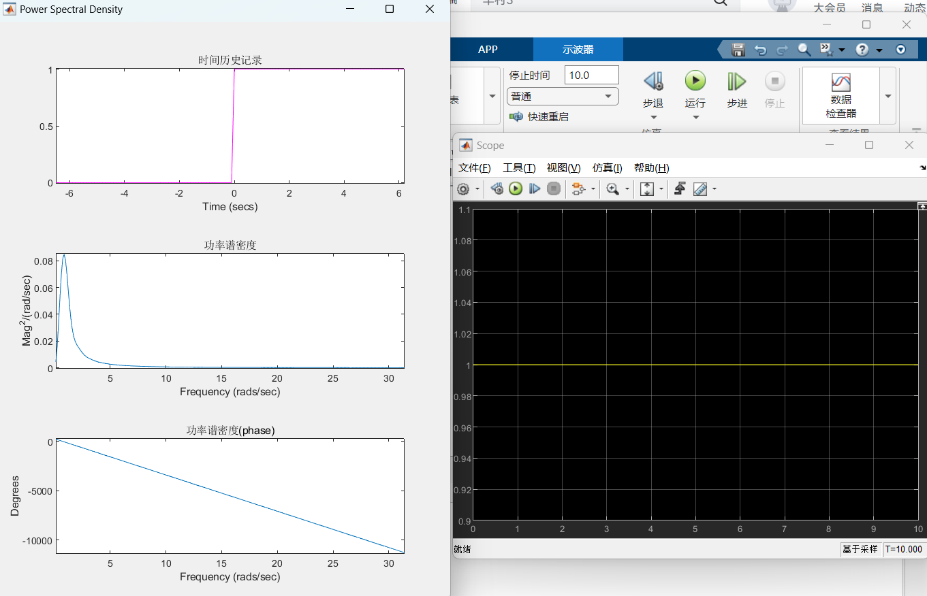 Increasing the amplitude again by 0.5 gives the following result:

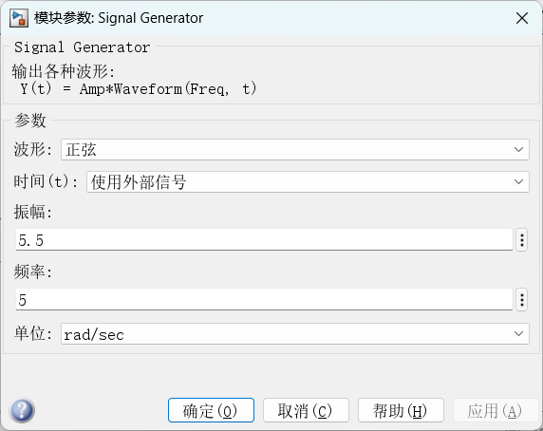

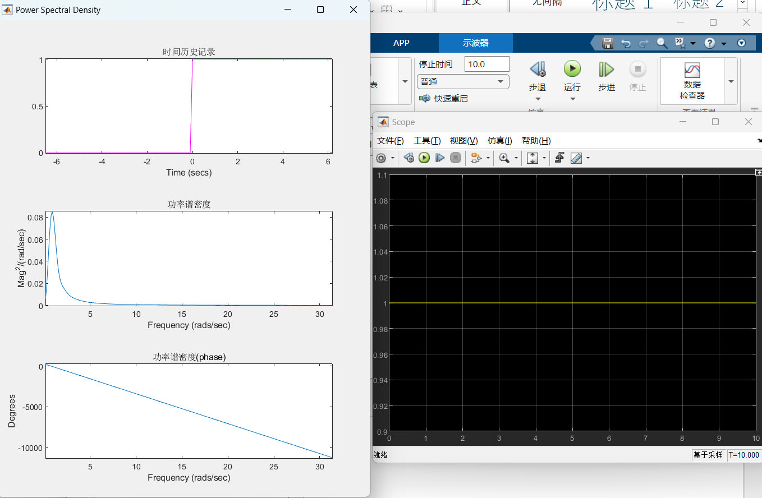 In order to study the oscillation characteristics of the modulator, the frequency was increased and decreased by 300Hz compared with the original data, and the following results were obtained:

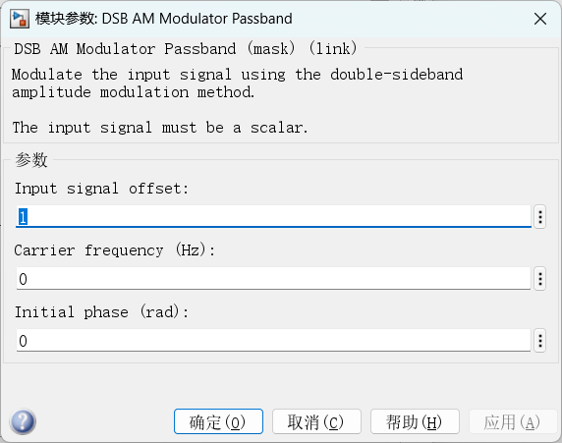

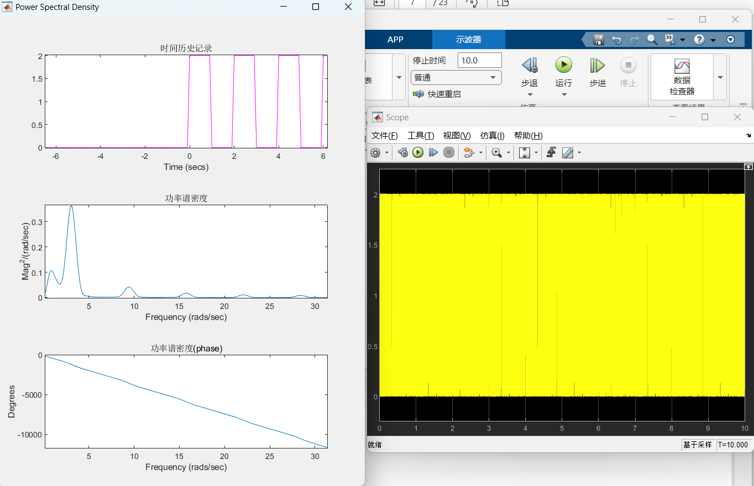

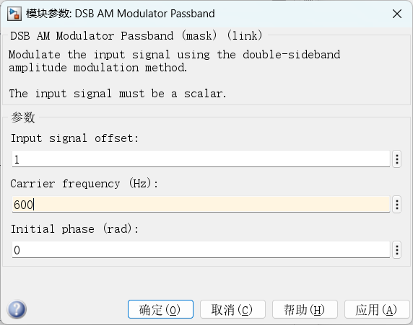

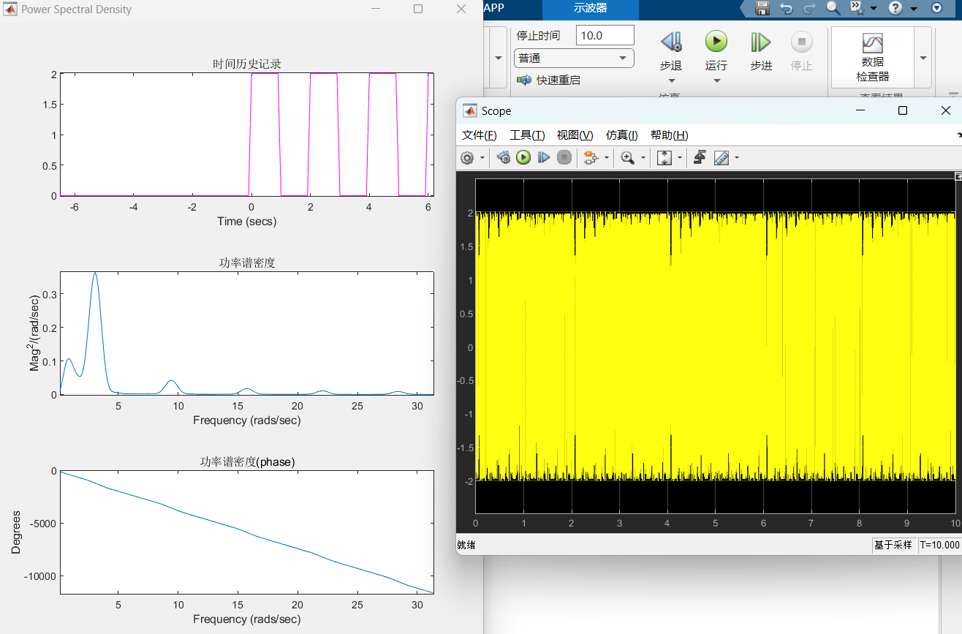

For the random number generator, take the same measures as above, and get the following results:

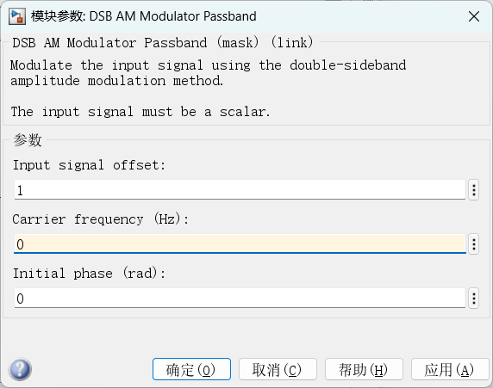

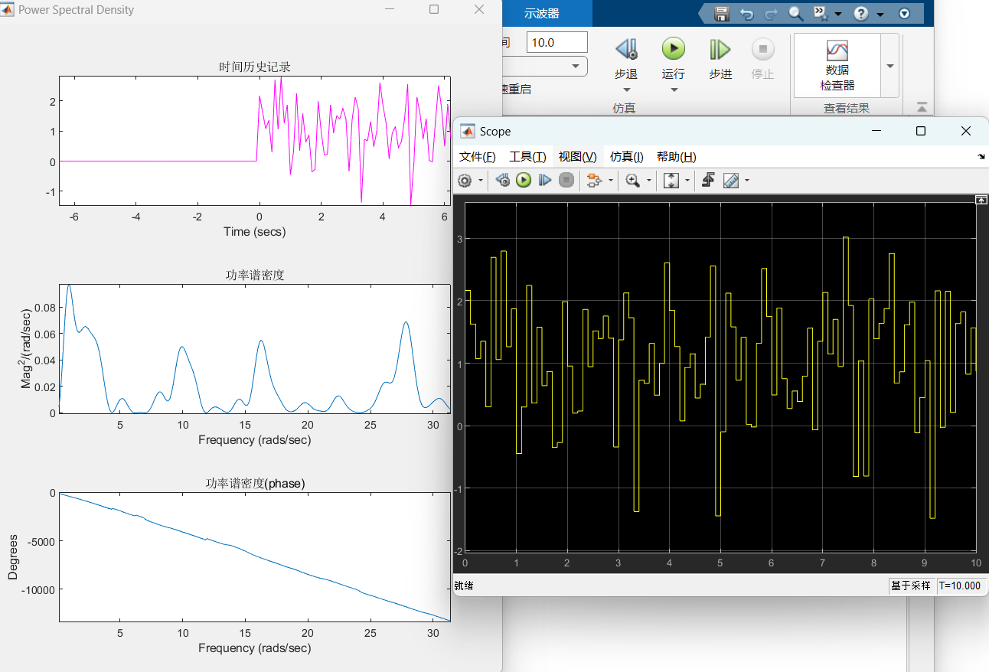

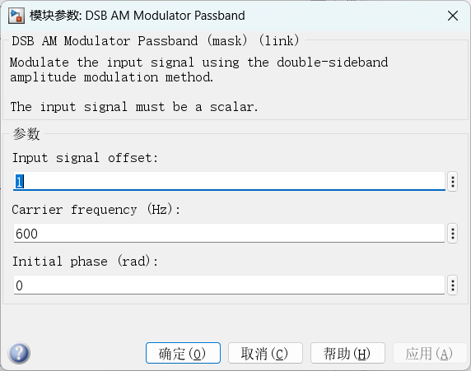

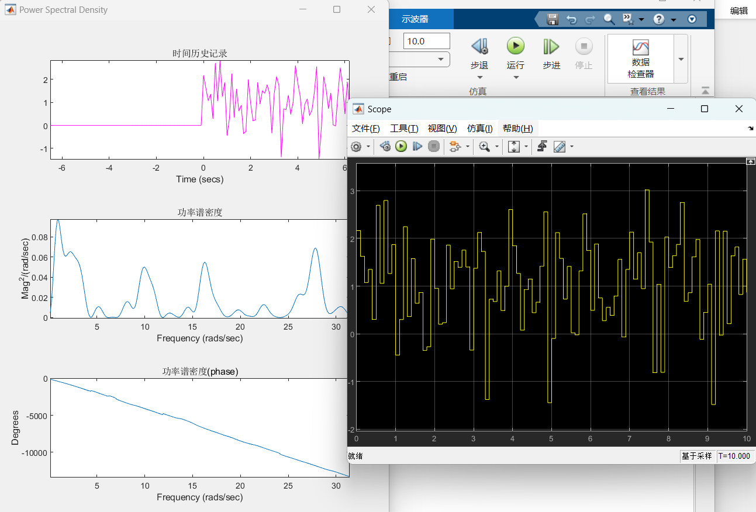

The characteristics of the AM-oscillation with the carrier suppressed for different modulation oscillations, the experimental results are as follows:

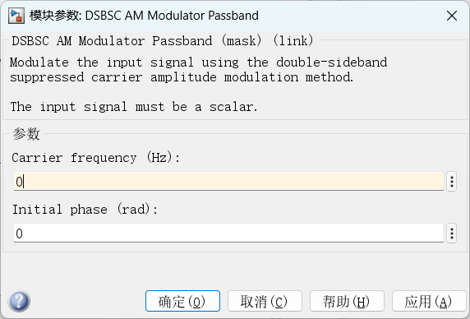

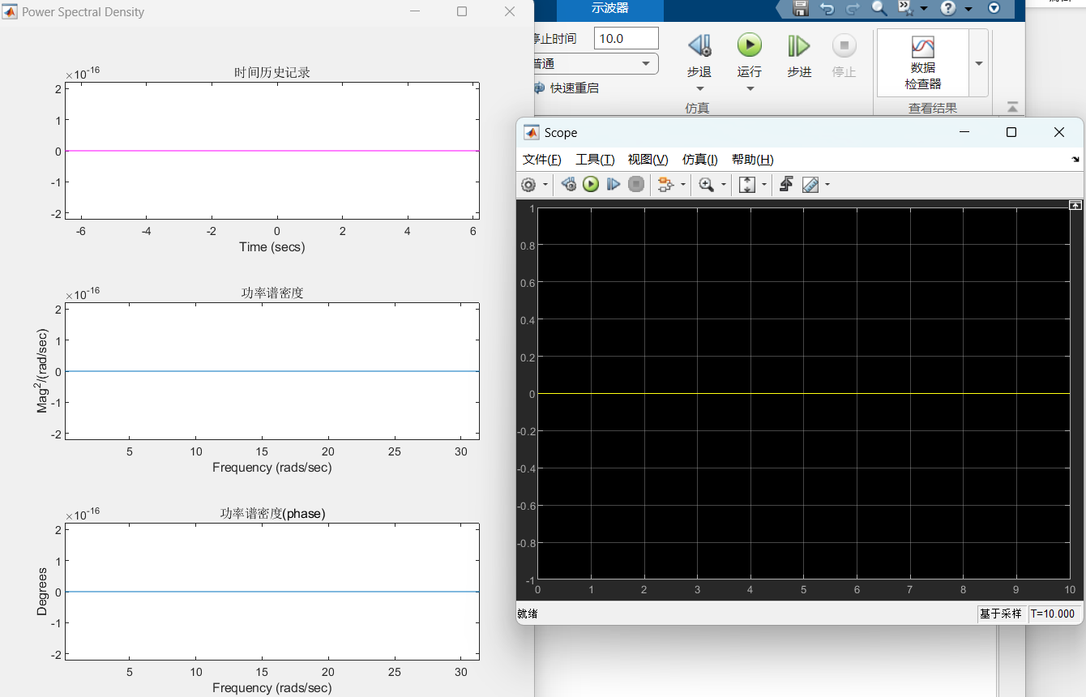

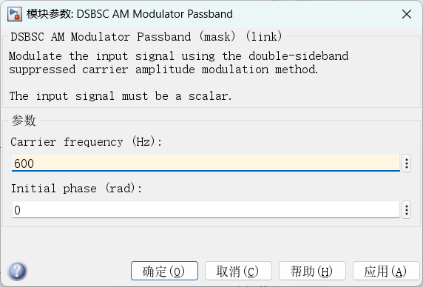

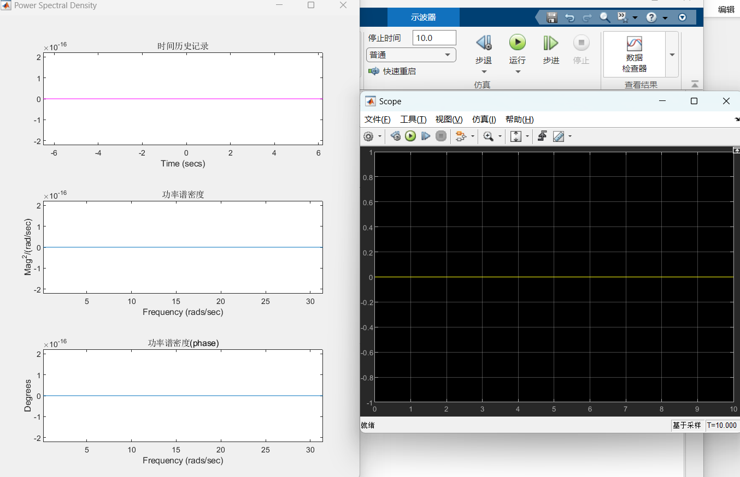

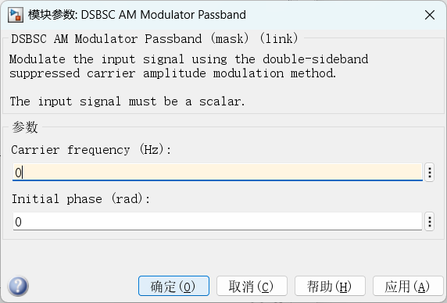

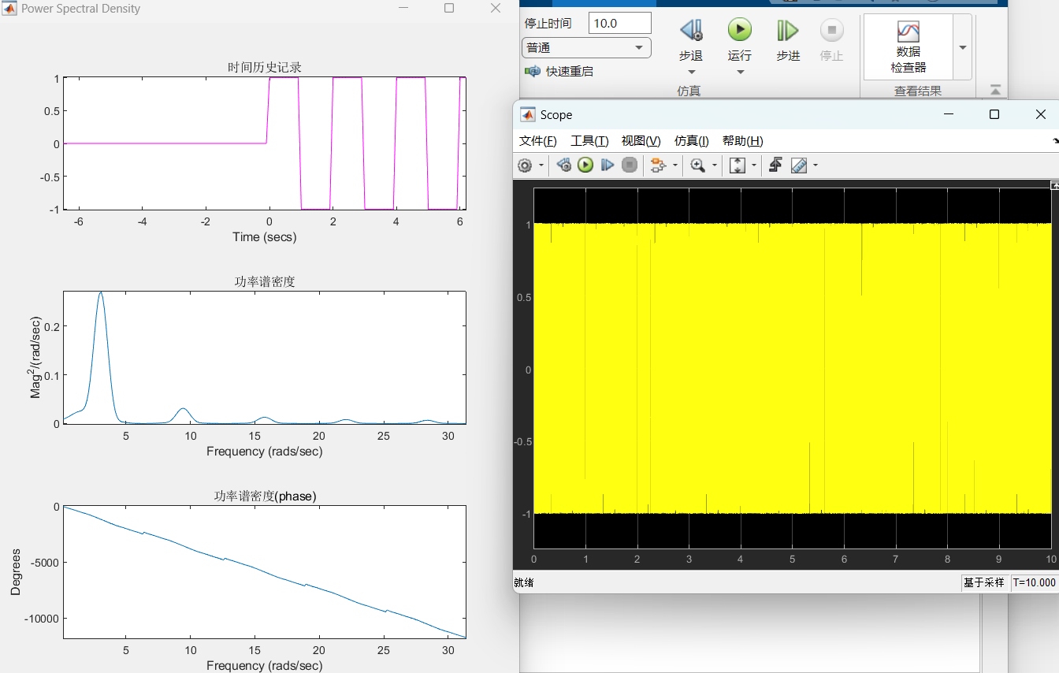

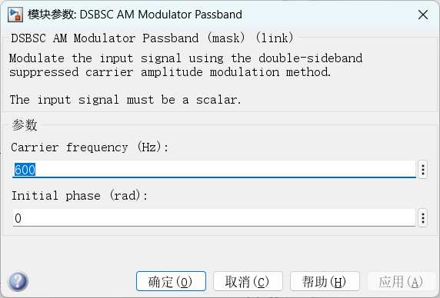

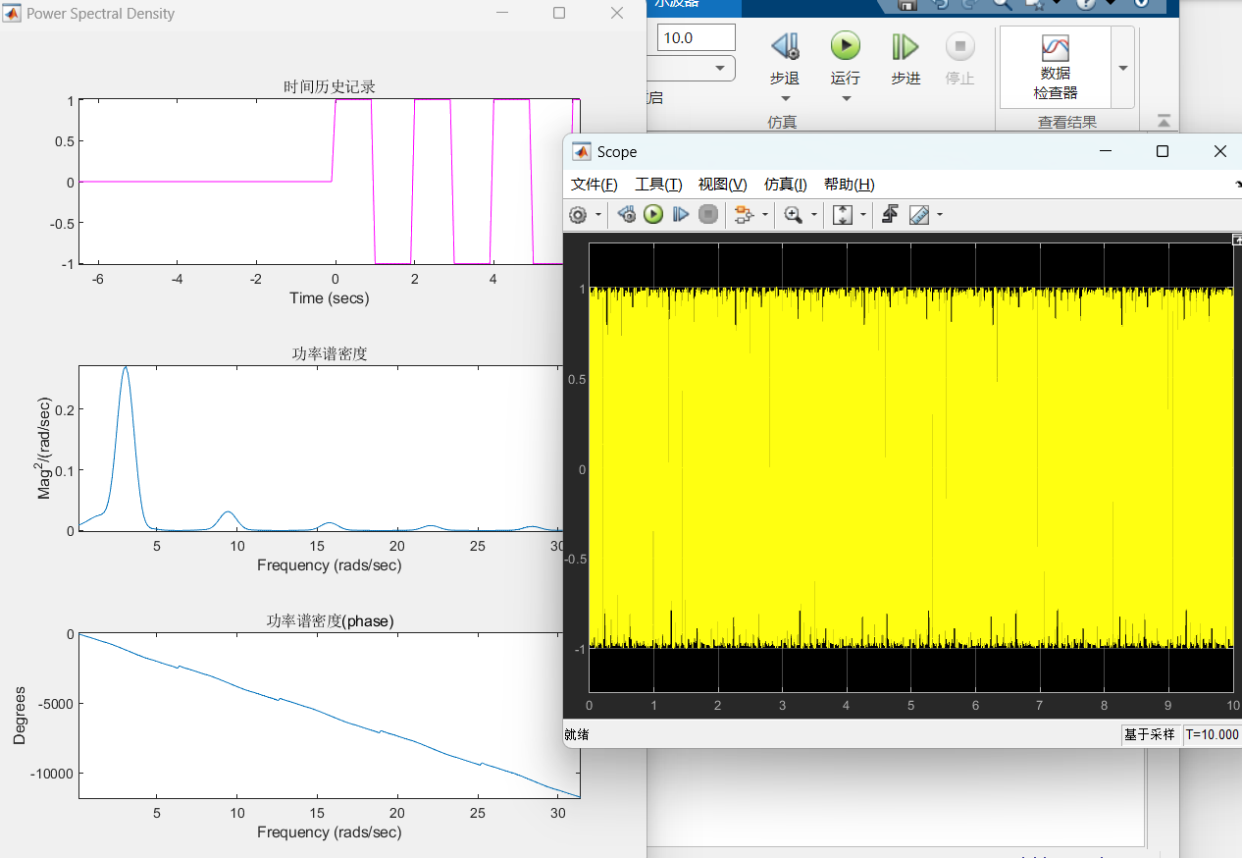

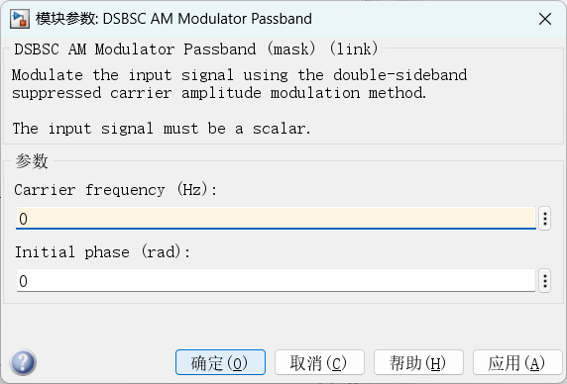

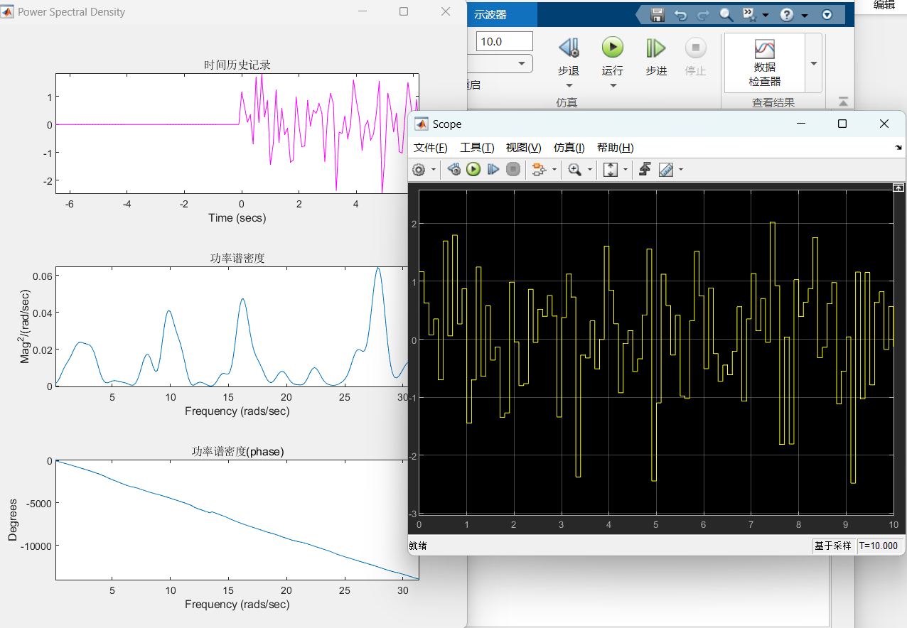



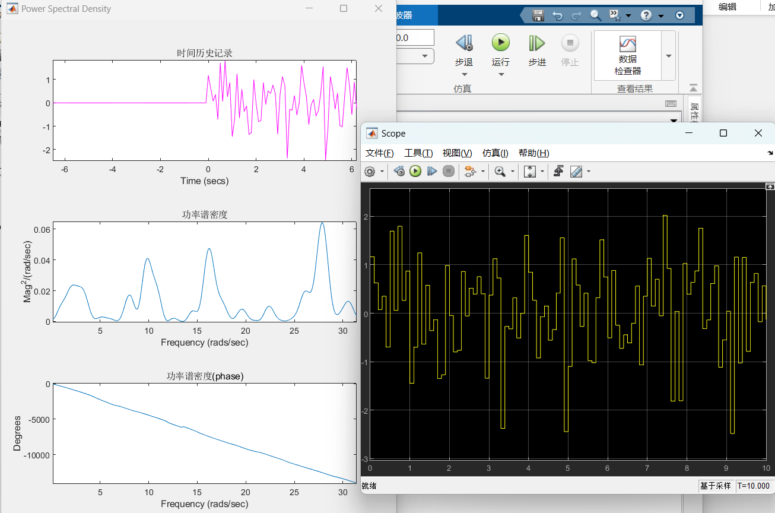

The characteristics of the AM-oscillation with the carrier suppressed for different modulation oscillations, the experimental results are as follows:

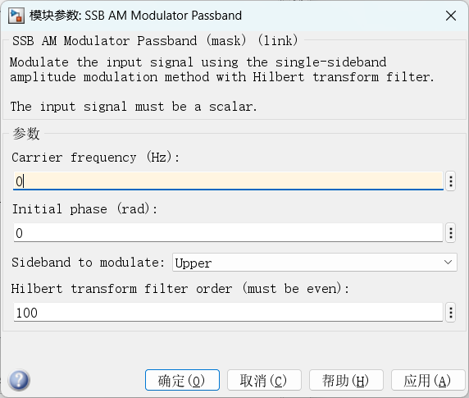

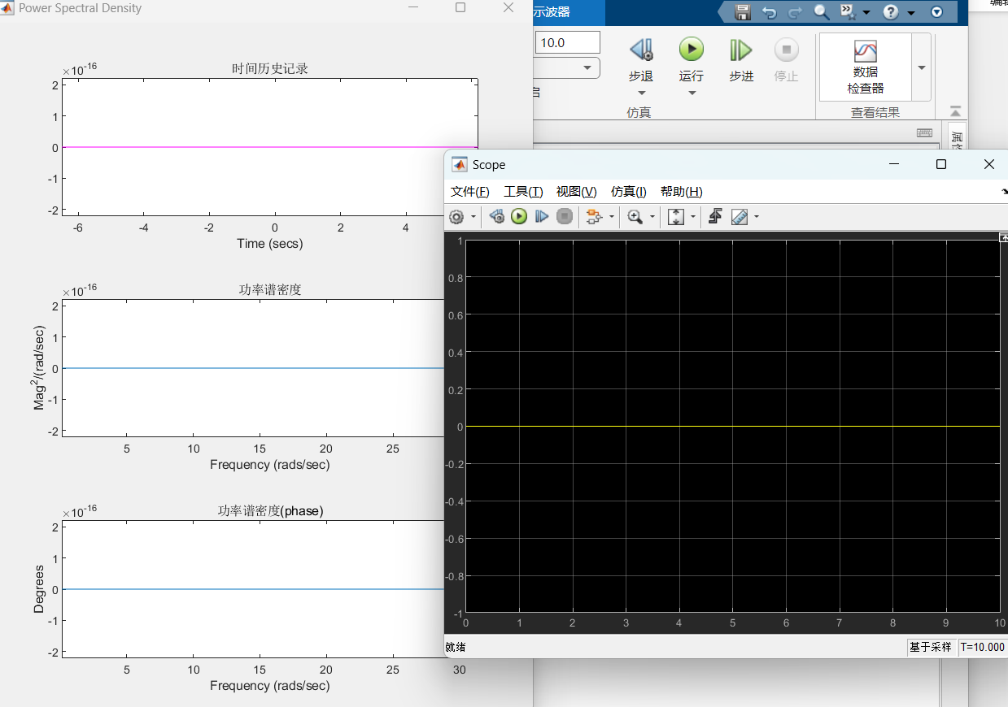

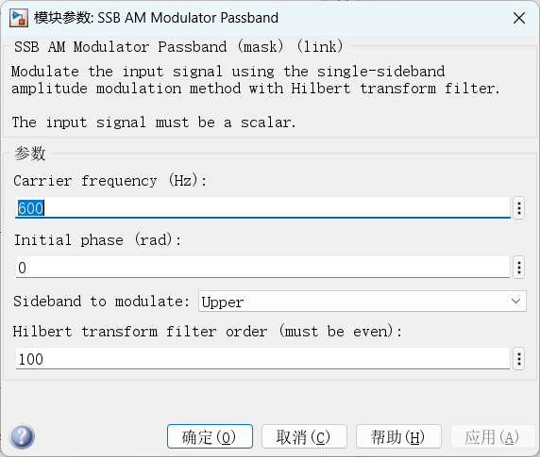

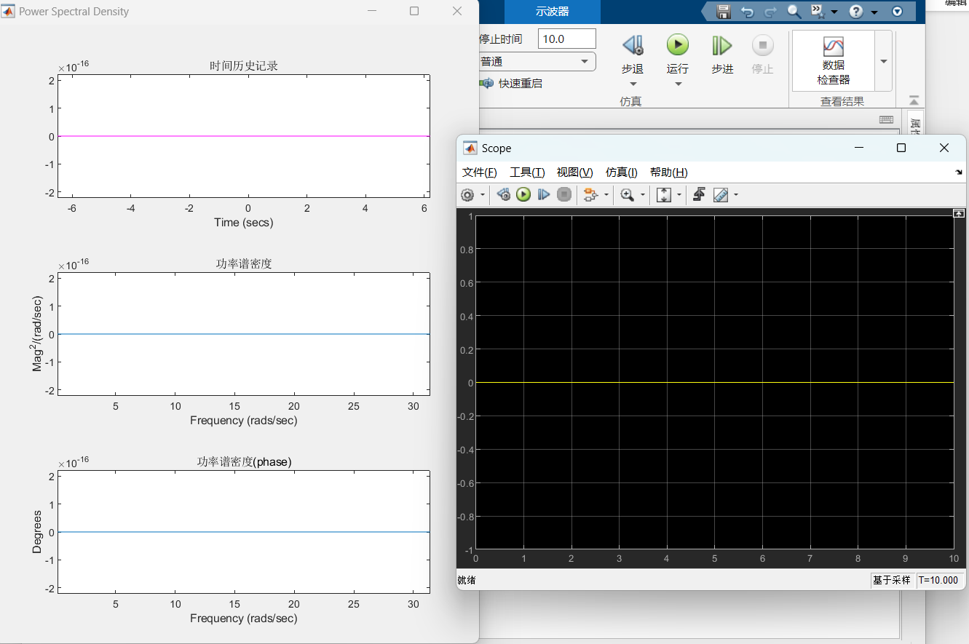

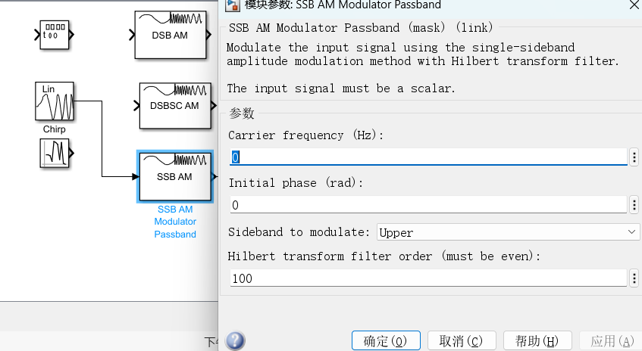

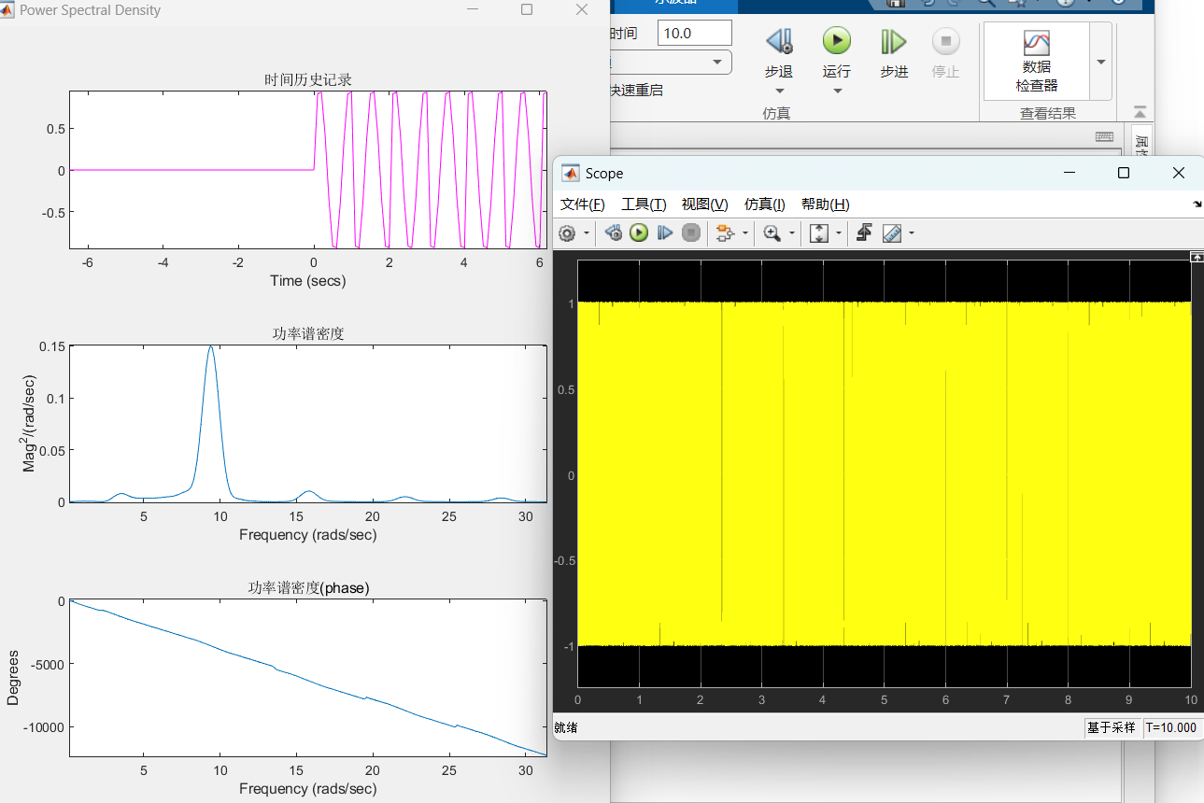

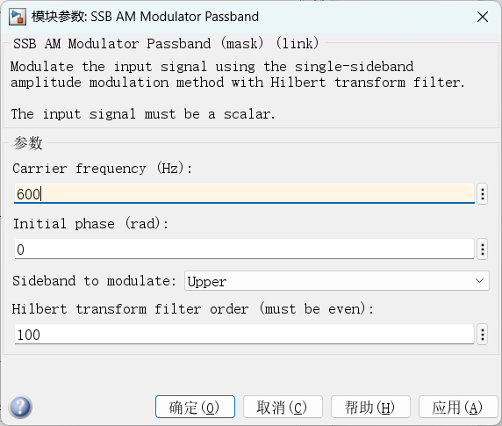

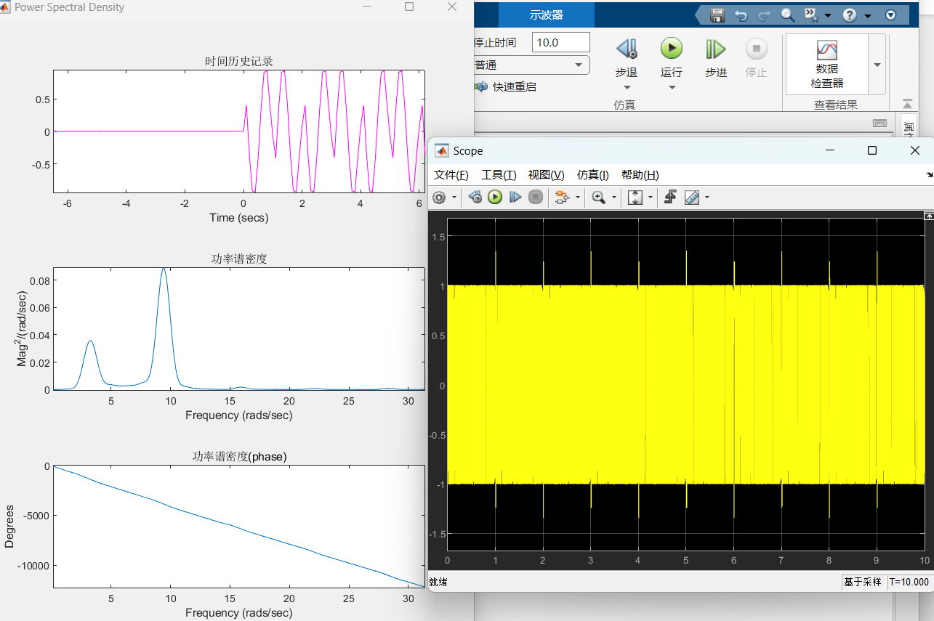

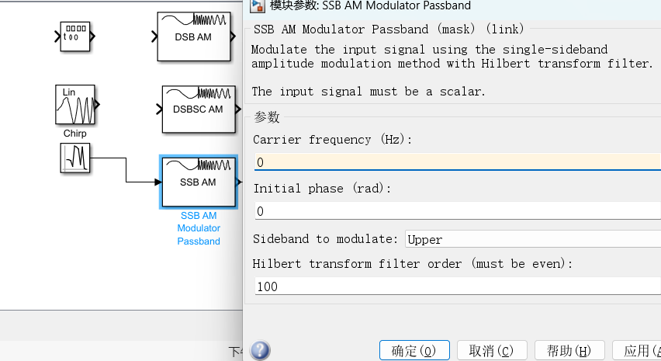

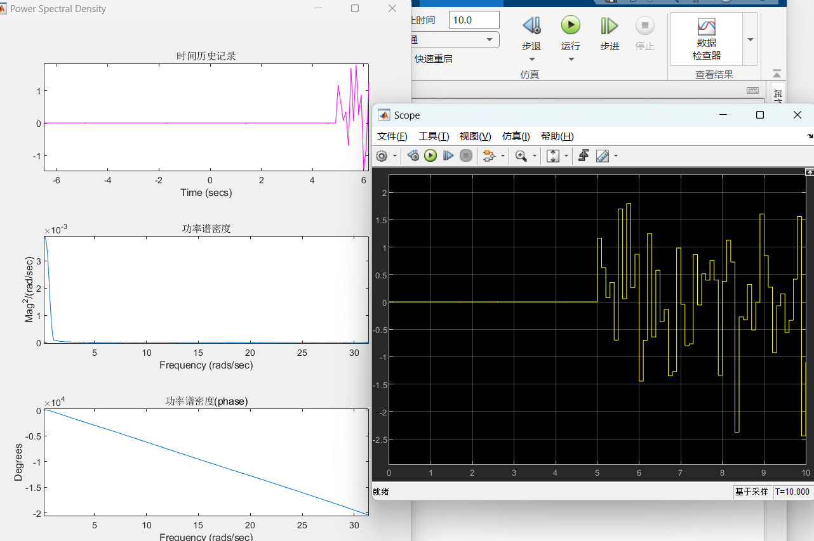

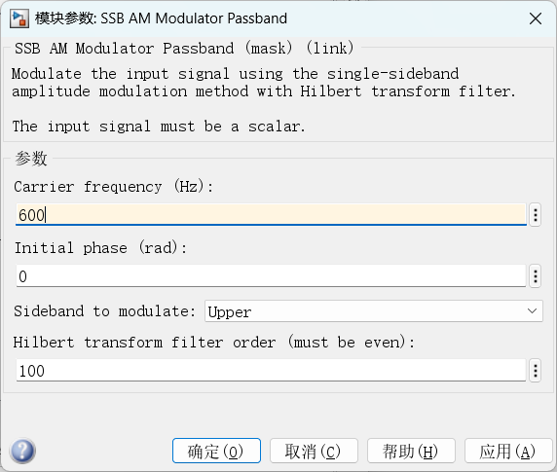

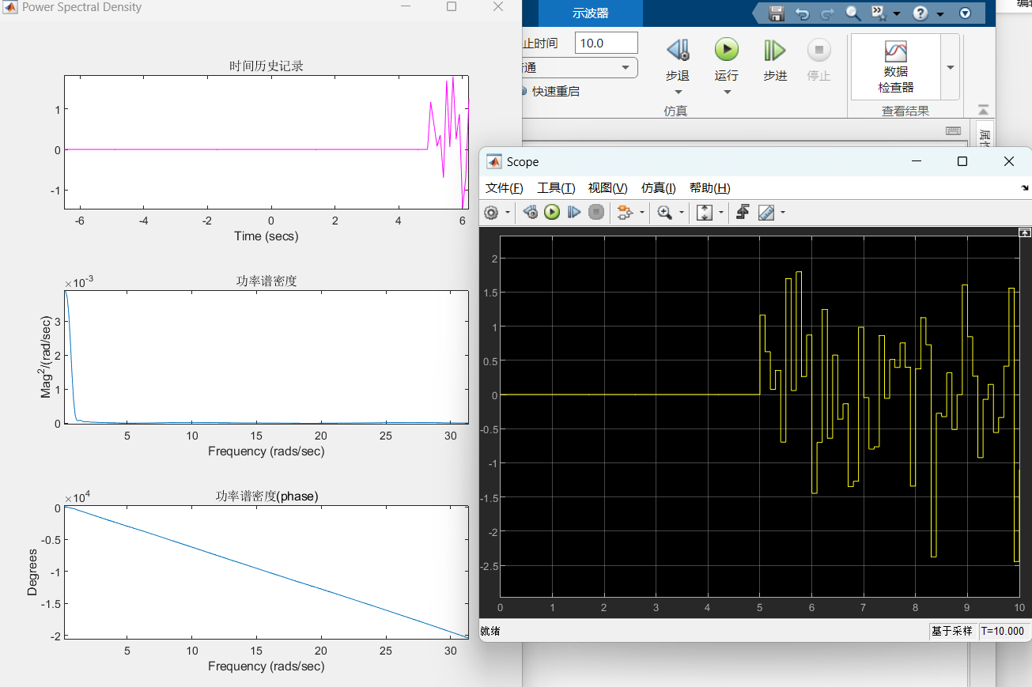

3.Investigate the dependence of the frequency deviation ω d and modulation index β on the frequency Ω and amplitude of the modulating signal for an oscillation with frequency modulation. (1) To do this, assemble the research scheme according to Figure 14. Set the initial data for the frequency modulator (FM Modulator Passband) as follows: Initial phase (rad) - 0; Modulation constant (Hertz per volt) - 100; Sample time - 0.00001; Symbol interval - inf; Carrier frequency (Hz) - according to the source data option. Initial data for the signal generator (Signal Generator) set the following: Wave form - sine; Units - Hertz; Amplitude - according to the source data. By changing the frequency of the Signal Generator (Signal Generator) from 1Hz to 60Hz in steps of 5Hz using a spectrum analyzer (Power Spectral Density), measure the frequency deviation (maximum deviation from the average value). Record the resulting diagrams in the report. Construct a graph of the frequency deviation versus the frequency of the modulating signal. Using the expression for the modulation index, construct the dependence of the modulation index on the frequency of the modulating signal.

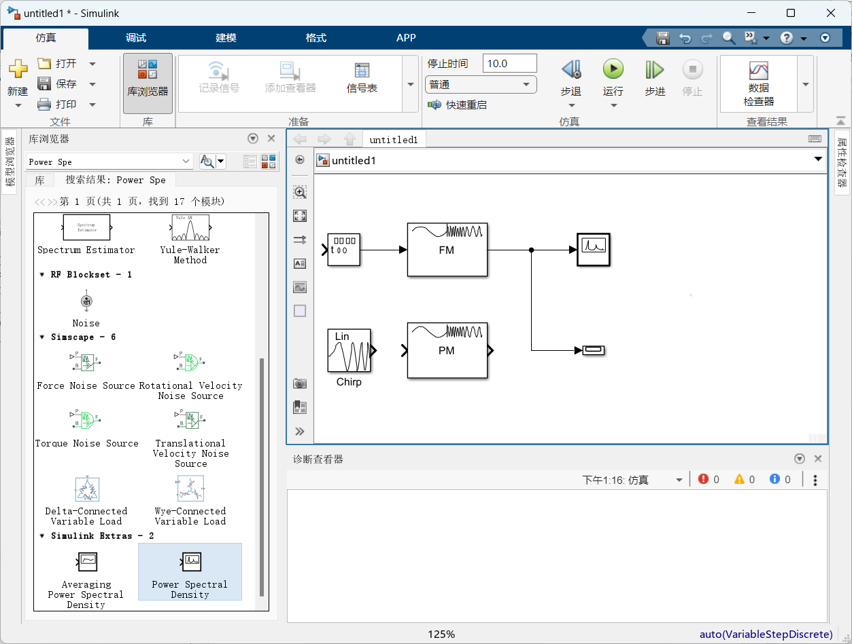

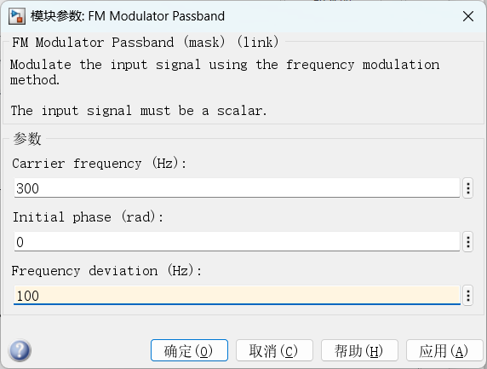 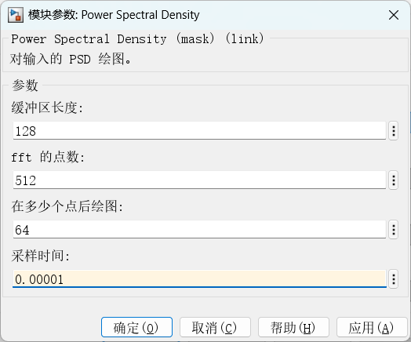

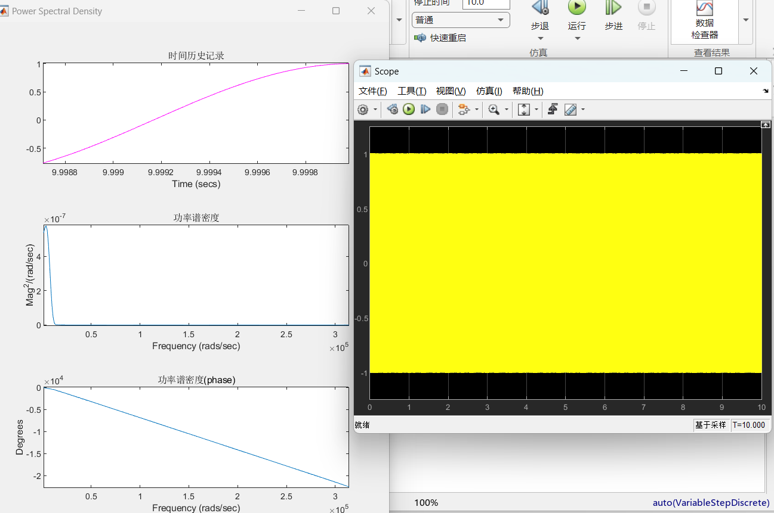

(2) Set the Signal Generator frequency to 2Hz. By changing the amplitude of the signal generator from 1 to 9 using a spectrum analyzer (Power Spectral Density), measure the frequency deviation and plot the dependence of the frequency deviation on the amplitude of the modulating signal. Disconnect the signal generator from the input of the frequency modulator (FM Modulator Passband) and connect the generator of the changing frequency (Chirp). Set the initial value of the frequency of this generator Initial Frequency - 1Hz, and the final value - Target frequency - 100Hz. Explore time and frequency charts in this mode. Record the resulting diagrams in the report. Draw conclusions. 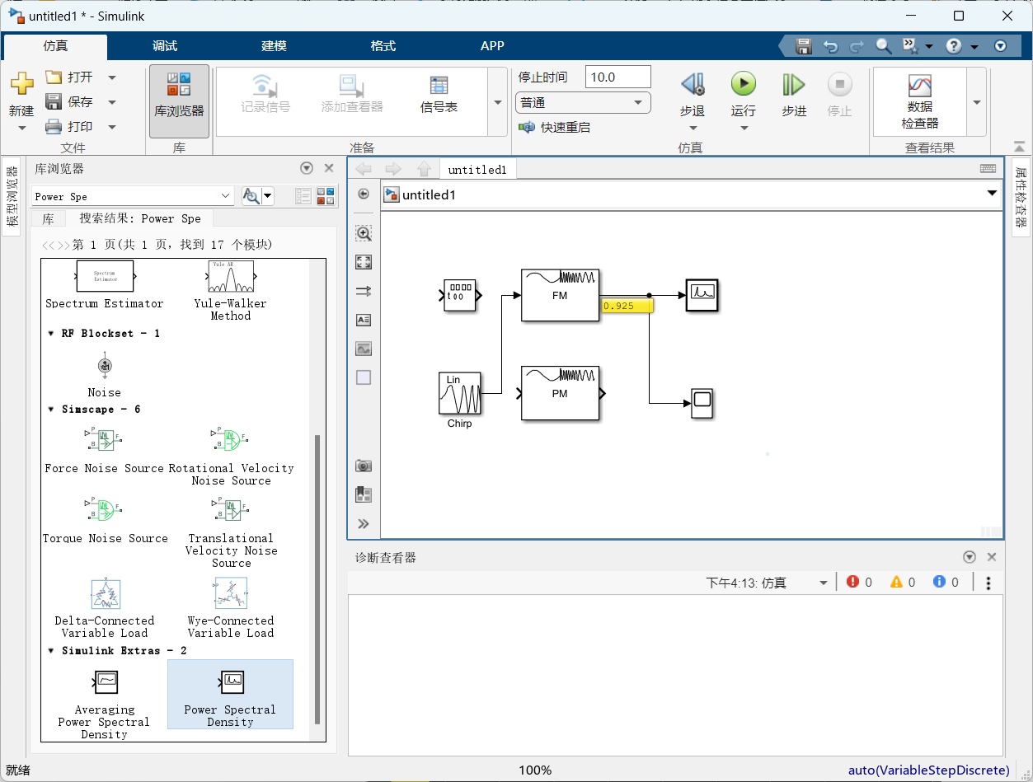

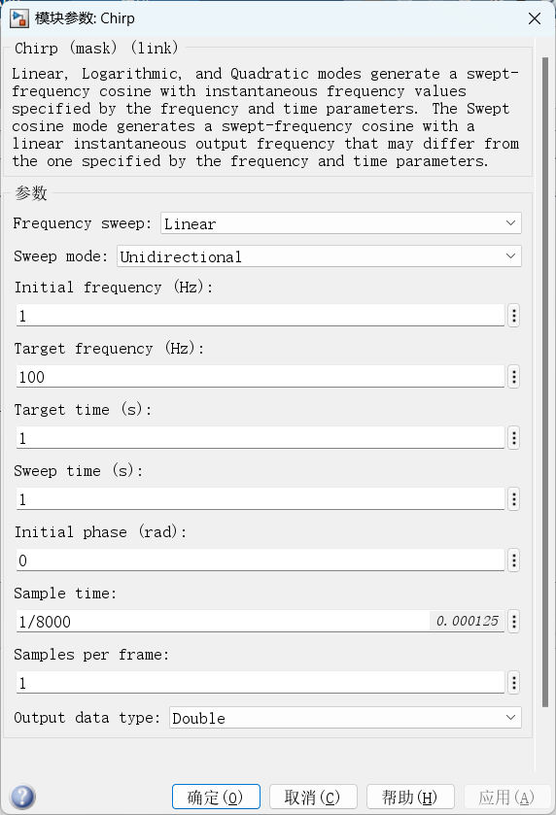

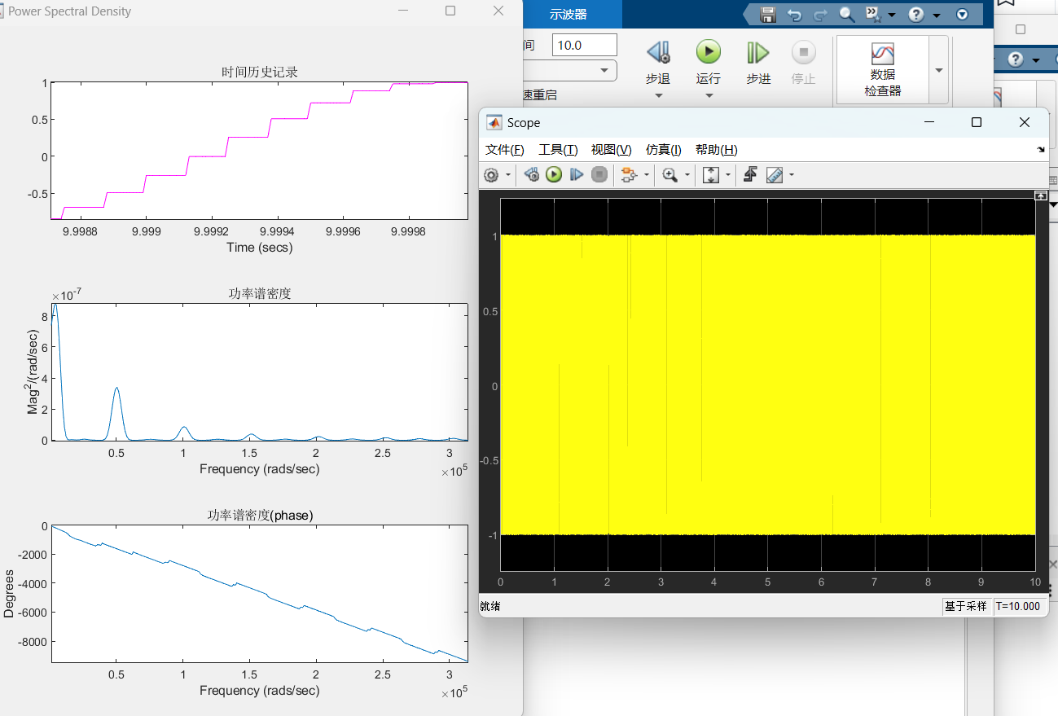

4. Investigate the dependence of the frequency deviation and modulation index on the frequency and amplitude of the modulating signal for an oscillation with phase modulation. Set the initial data for the phase modulator (PM Modulator Passband) as follows: Initial phase (rad) – 0; Modulation constant (Radians per volt) - 10; Symbol interval - inf; Carrier frequency (Hz) - according to the initial data. Set the initial data for the signal generator as follows: Wave form – sine; Units - Hertz; Amplitude - according to the original version. By changing the frequency of the signal generator from 1Hz to 60Hz in 5Hz steps, use a spectrum analyzer (Power Spectral Density) to measure the frequency deviation (maximum deviation from the average value). Record the resulting diagrams in the report. Construct a graph of the frequency deviation versus the frequency of the modulating signal. Using the expression for the modulation index , construct the dependence of the modulation index on the frequency of the modulating signal.

